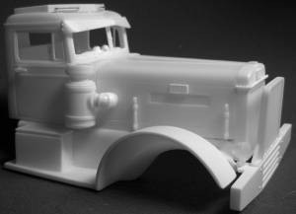
Silver State Specialties
5416 Via De Palma Drive
Las Vegas, NV 89146
United States of America

http://www.silverstatespecialties.com
silverstatespecialties@hotmail.com

- - - Quality Resin Model Truck Accessories - - -

Kit P-6: 1949-52 Peterbilt 380 Conversion Kit Instructions

Thanks for purchasing my products! I have worked long and hard to bring you the best possible kits I could produce. However, since Peterbilts were hand-built for each customer, a great number of variations were possible. These variations even exist in my castings, as I continue to improve and refine my techniques in order to improve the products themselves. However, this doesn’t mean that I will sell junk. If you are ever dissatisfied with any of my products, feel free to contact me at any time so that I may provide a remedy.

All parts, unless otherwise noted, are cast in two-part polyurethane resin. It is strong and flexible, but as with kit plastic, it can also be easily broken. It can be heated and bent/formed just like kit plastic. However, it is softer than styrene (model kit) plastic, so use caution and care when filing/sanding/cutting parts. I use a strong silicone-based mold release, and residue from this can be found on most parts. To remove this mold release, you can soak the parts for 1-2 hours in a 50/50 mixture of Westley’s Bleche-White and water, inside a plastic Tupperware container. Do not soak for longer than 2 hours, as the mixture may attack the resin. In fact, keep a close eye on the parts while they are soaking. Be sure to wear thick rubber cleaning gloves and avoid getting the Bleche-White on your skin, as it is caustic and will cause burns and irritation. Remember Safety First!

After soaking the parts to remove the mold release, I highly recommend a good scrubbing with grease-cutting dish soap, such as Dawn or Ivory, and a soft toothbrush or scrub brush. Rinse thoroughly, and allow to dry before working with the parts. Again, anytime you are dealing with harsh chemicals such as Bleche-White, be sure to wear protective gloves and eyewear, and avoid skin contact.

Do not breathe any of the dust generated when sanding/filing resin parts. It can be hazardous to your health! Wear appropriate dust masks or breathing apparatus, and avoid sanding or filing while in confined spaces. If possible, wet-sand parts in order to keep dust levels at a minimum. It is recommended to lightly sand parts with 800-1200 grit sandpaper to improve surface adhesion of cements and paint.

You can cement parts with CA-type adhesives, also known as “super glues”. 2-part epoxy is also effective. Liquid cement for styrene plastic will NOT work!

Thanks again for purchasing Silver State Specialties products, and I hope you get many hours of enjoyment from them!

Warren Willis Jr.

Parts Layout

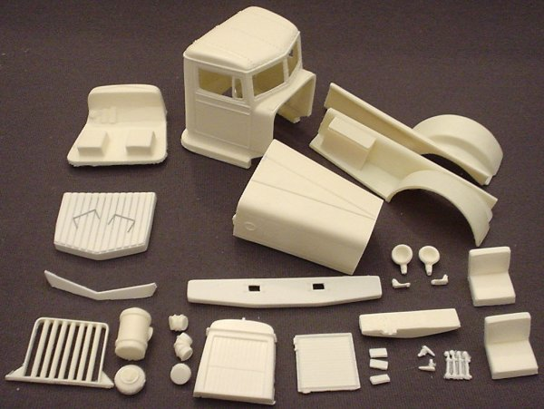

Parts Layout:

Cab (2) Door Handles
Hood (4) Hood Latches
(2) Fenders (3) Square Peterbilt Emblems
(2) Seats Radiator
Interior Bucket Radiator Cold-Weather Shutters
Dash Bumper
Cab Roof Guard (2) Headlight Housings
Cab Sunvisor (2) Headlight Lenses
Air Cleaner Body
Air Cleaner Cap (Large and Small Cap)
Air Cleaner 90° Elbow
Grille Guard

Kit General Information (Courtesy of Tim Ahlborn)

The 380 Conversion Kit

Peterbilt offered the 380 conventional from 1949-1954. A heavy duty 390 was available, having wider rear wheel spacing, and wider rear axle spacing. Both the 380 and 390 were cosmetically similar.

Wheelbases ranged from 194 to 240 inches.

Cabs measures 61 inches from the frame to roof. This series was referred to as "high mount” cabs, due to the taller position.

This series had rounded fenders without skirting that the 350 series had.

This series would be ideal for loggers, dumpers and mixers and other heavy-duty applications.

STANDARD FEATURES:
Single roof mounted air horn
Right-side mounted air cleaner on diesels
Single color cab and chassis
5-hole Budd wheels

OPTIONAL FEATURES (only a couple):
Waukesha, Cummins, Hall-Scott Engines
Gas or Diesel
Bucket or full bench seat
Radiator Guard
Cab Roof top platform/guard (standard on some models)
Defroster fan
Fog Lights
Spot Light
ICC lights on cab roof

Of Course, being Peterbilt, virtually anything was available at the time. Using the variety of aftermarket resin parts, and kitbashing, virtually any Peterbilt can be built. Unless you build your model to replicate a fresh-from-the-factory look, you can mix and match parts from various trucks to get the Peterbilt of your desires. Old Peterbilts never die!

Kit Assembly

Begin by inspecting all parts for breakage and defects. Very slight blemishes or variations may be present (nobody’s perfect!). Cut away all casting sprues and flashing, especially the casting sprue on the bottom of the cab:
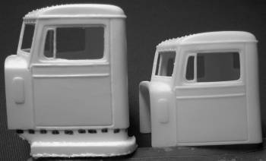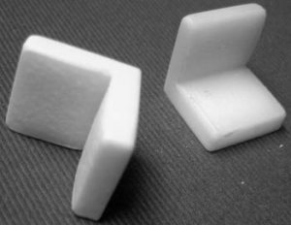
The material below the dotted line (cab on left) needs to be removed with a razor saw or wire cutting pliers, so that the cab looks like the one on the right. The seats need their casting sprue cut away also, as shown above. Various other parts need their casting sprues removed.

Cement the hood to both fender units. Ensure that the front of the hood is flush with the front of both fenders, since the radiator will be fitted here later.
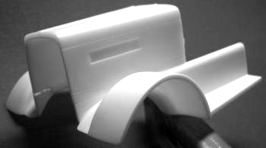
Ensure that the fenders lie flat during assembly.
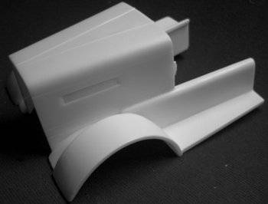

Install the cab roof guard. This will require some modification, as there was a great deal of variation in the designs as well as mounting methods. You could file the center of the roof guard to fit flush against the roof, or your could install mounting “legs” for the guard to rest on. You could also file the guard very thin; the choice is yours.
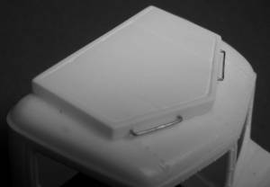
You can add grab handles by using staples, as shown above.

Cement cab to hood and fenders.
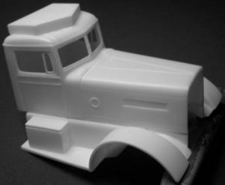
Make sure that the bottom of the cab is flush with the inside of the fenders, so that the interior tub will fit inside the cab later.
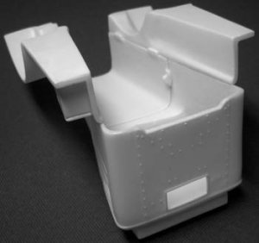

OPTIONAL: Assemble air cleaner assembly. Not all early Peterbilts used external air cleaner housings. Most diesels usually did, but typically gas and butane engines did not; they used internal, under-hood air cleaners. Be sure to remove the casting sprue remnants from the bottom of the air cleaner housing, elbow, and cap, as shown below:
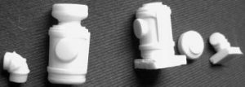
Cement the air cleaner top (large or small cap) to air cleaner housing, but don’t attach the elbow yet. Cement the air cleaner to the right side of the cab, being sure to use the elbow as a guide to ensure proper alignment:
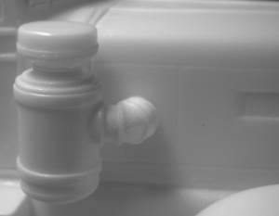

Assemble interior. Install seats and dash. Cement dash on styrene strip (included) to mount across interior bucket. Ensure that the dash is aligned properly by test fitting into cab, and raising/lowering as necessary. Using a donor kit or spare parts (not included), install gearshift levers, steering wheel, and steering column.
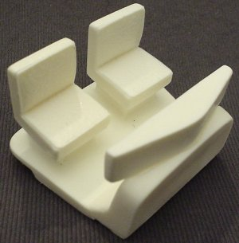

Insert Interior Bucket Into Cab.
Slide the interior bucket assembly into the cab. You may need to slightly file or sand the sides of the interior bucket or the inside of the cab to ensure a good fit.

Attach Radiator to Hood/Fenders.
If you are going to chrome-plate the radiator, you may want to leave this step until last. Otherwise, cement the radiator to the hood and fenders assembly:
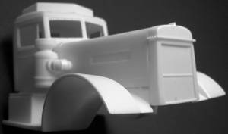

OPTIONAL: Attach Radiator Shutters.
If you are modeling a truck being used in extremely cold weather, you may want to add the cold-weather shutters. If so, simply cement it to the front of the radiator:
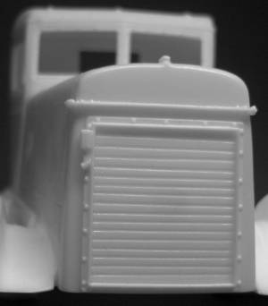

Cement Headlights to Radiator.
Mount the headlights to the sides of the radiator, approximately one-third of the way up the side:
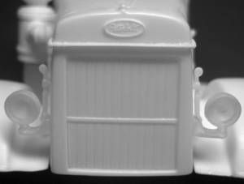
You might have to file/sand the edges of the headlight lenses to ensure a proper fit inside the headlight housings.

Attach Emblems, Hood Latches, and
other items as you may wish. Emblems may be carefully removed from their casting backing with a razor saw, and then filed down to scale thickness. Place one at the top of each butterfly hood side (right and left), and one on the front of the radiator tank:

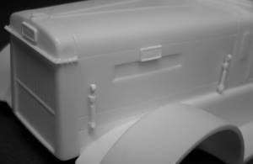

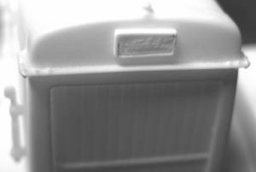

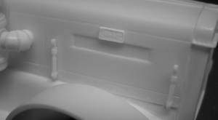
2 hood latches are needed for each side of the hood. Cement with the round portion at the top. Emblems are placed at the top of the butterfly hood side, roughly 2 scale inches (1/25-scale, or centered) from the radiator.

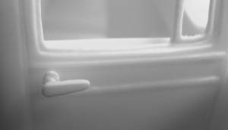
Cement the door handles to the doors, one per side.

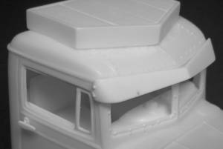
The sunvisor may be attached as well, if you so desire.

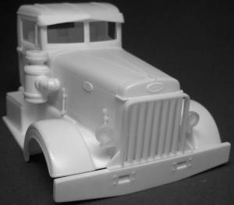
The grille guard can simply be glued on to the top of the bumper, once mounted to your model.

